FEATURES

- 4 bits of individually programmable IO
- 5V TLL inputs and outputs
- Latch input values for later reading

DESCRIPTION
Does cool stuff
FUNCTIONAL BLOCK DIAGRAM

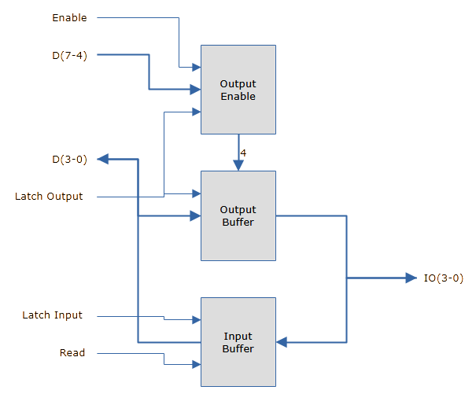

SCHEMATIC DIAGRAM

